Davidson County’s Centennial Celebration 1922
Submitted by Tonya R. Hensley
As we come together to celebrate Davidson County’s Bicentennial, let us step back in time and discover how we celebrated our first 100 years.
The Davidson County of 100 years ago was much like it is today. We were slowly recovering from fighting a war and experiencing a deadly pandemic. However, the 100th birthday of our county gave us a reason to celebrate. The first centennial celebration was as part of the Davidson County Fair from the 26th of September through the 29th of September 1922. It was decided to hold the revelry at this time instead of the actual anniversary of the creation of Davidson County, which was when the State Legislature ratified the bill on 29 November 1822. The official Centennial Day would be 26th September 1922. The pageantry of these four days in September served to highlight all areas of the county and the importance of agriculture, commerce, education, food, and family in our communities.
These festivities were organized by a committee made up of the Lexington and Thomasville Rotary Clubs in conjunction with the Lexington Chamber of Commerce and the Davidson County Fair. Later other organizations such as the ladies’ civic clubs joined the efforts as well. It was decided that Col. Wade H. Phillips would represent Lexington and serve as the chairman of the Centennial Committee, while Charles Franklin Finch would represent Thomasville on the same committee.
Wade Hampton Phillips at that time was a noted lawyer, historian, and captain in the National Guard. He was born on 7 July 1879 in the post office at Yadkin College where his father H.T. Phillips was serving as postmaster. Wade attended Yadkin College, Erskine College, and law school at the University of North Carolina. Philips represented Davidson County in the state legislature in 1913, and he went on to serve his country in the military at the Mexican border with the National Guard and then during WWI with the First Division. He died on 4 December 1968 and is buried at Forest Hill Memorial Park in Lexington, NC.
Charles Franklin Finch was born in Randolph Co., NC on 13 August 1868 to Alfred Finch and Lucy Andrews Finch. He was a prominent Thomasville businessman selling lumber and other merchandise. Along with his brother, Thomas, he purchased Thomasville Furniture Company in 1907. He died in Forsyth Co. NC on 18 August 1937.
The various subcommittees were formed with H.B. Varner in charge of entertainment; J.T. Hedrick was the business statistics and float chairman; James Leonard, Mayor of Lexington, was the grand marshal for the parade; G.L. Hackney was in charge of the manufacturing exhibits; S.G Hasty and J. H. Cowles were placed in charge of the educational components of the celebrations; and finally, Dr. J.C. Leonard became the official historian and would later publish his widely acclaimed book, The Centennial History of Davidson County.
An important theme running through the celebration was the spotlight placed on education and industry. After the committee chairmen were chosen, the plans began in earnest. It was announced that the “world’s largest chair” would be completed and erected in the town square of Thomasville to highlight the fact that Thomasville was known as the “Chair City.” The business districts in both Thomasville and Lexington were encouraged to decorate their windows along with the major manufacturers such as Dixie Furniture and Thomasville Furniture Industries participating in the parade as well as the exhibitions. The main schools in the county were inspired to create and perform a pageant that represented the historical eras in Davidson County’s story.
Along with the centennial party, it was expected that the Davidson County Fair for 1922 would be the largest up to that point with the most complete farm exhibitions of livestock and produce to ever grace the halls of the fair. Additionally, the attendance for the 1922 Davidson County Fair was anticipated to top all other previous events with people coming home from other states like the “Lexington’s” Georgia Colony, located in Albany, Georgia, such as Dermot Shemwell.
A boost to the celebrations occurred when Mrs. Edith Vanderbilt, President of the NC State Fair agreed to attend. The Rotary Clubs of Lexington and Thomasville hosted a luncheon in her honor, but due the lack of space had to limit the attendees to the club members and the Centennial Committee.
The Centennial Celebrations during the Davidson County Fair week began with Centennial Day on the 26th of September 1922. It opened with a parade featuring thousands of schoolchildren, hundreds of members of the Junior Order, other organizations, and parade floats. It moved up Main Street to the fairgrounds, located where the high school is now, which opened at 10:30 a.m. Mrs. Edith Vanderbilt spoke. The day continued with a presentation of an historic sketch of Thomasville, the school pageant featuring the historical events in Davidson County history. Rounding out the first day was a free program from the Ferris Wheel girls, Thomasville athletic contests and ended with a concert by the Royal Hussars Band complete with fireworks.
On 27th September 1922, the second day of the focus was on Thomasville. Thomasville Day events were similar to Everybody’s Day held each September. There was a presentation on Lexington, band concerts, a livestock parade, a county-wide horseshoe pitching contest, a band concert, and fireworks.
On the third day, 28th September 1922, it was Lexington’s turn. An address was given by James Y. Joyner. Following Mr. Joyner was a band concert, fireman’s tournament, livestock parade, a freckle-faced boy contest, hog calling contest, and ended with a band concert with fireworks.
The last day of the celebrations, 29th September 1922, was Fair Day or Livestock and Agricultural Day. It featured band concerts, the finals in the horseshoe pitching contest, and a baseball game between Lexington and Thomasville. It ended as the previous days with a concert and fireworks.
According to the Union Republican, (Winston-Salem, NC) for 28th September 1922, over 150,000 people attended the Davidson County Centennial.
As we come together again to look back and celebrate another 100 years in our county's history, we can only marvel at what we have built upon since that week in 1922.
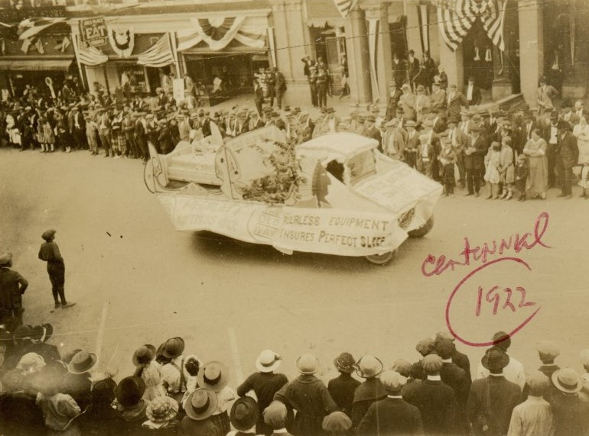
One of the floats in the centennial parage in 1922 amide the festivities celebrating Davidson County’s first 100 years. Used by permission of the Davidson County Historical Museum.
Sources:
Dispatch, (24 Aug 1922): Centennial of County Subject Rotary Meeting. Lexington, NC.
Dispatch, (28 Aug 1922): September 26th Date Chosen For Centennial Day. Lexington, NC.
Dispatch, (28 Aug 1922): Mrs. Vanderbilt Will Attend the Centennial Day. Lexington, NC.
Dispatch, (7 Sept 1922): Plans Advanced for Centennial and County Fair. Lexington, NC.
Dispatch, (11 Sept 1922): Marshals Appointed For Centennial Day Parade Here. Lexington, NC
Dispatch, (18 Sept 1922): Georgia Colony Is To Be Represented at the Centennial. Lexington, NC.
Dispatch, (21 Sept 1922): Daily Program For Four Great Days. Lexington, NC
Reid, J (29 Dec 1957). Wade H. Phillips: A Man of Many Roles. Journal and Sentinel, Winston-Salem, NC.
(1922). Union Republican, Winston-Salem, NC. Accessed 9 Dec 2021.

